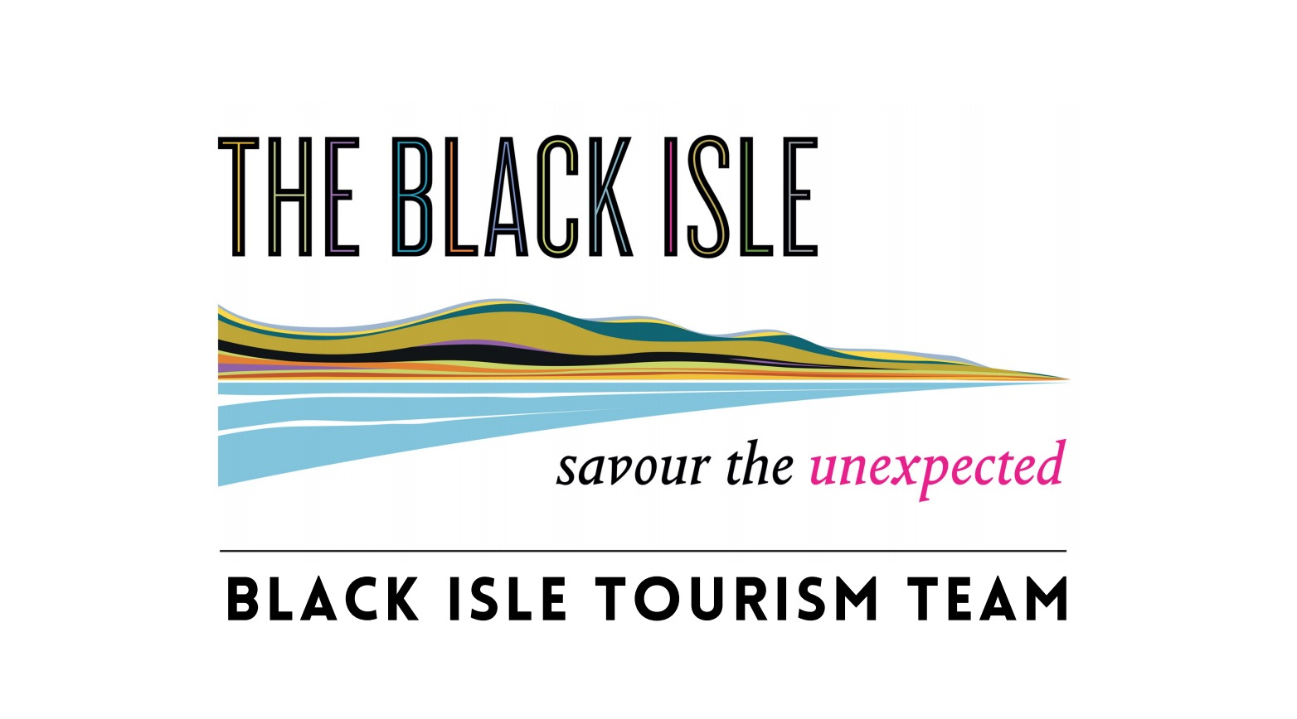
When completed please return to
Julian Paren
Black Isle Tourism Team
Marowan
Munlochy, IV8 8PF
Telephone 01463 811486
E-mail: julian.paren@gmail.com
Black Isle Partnership SC 223861

STANDING ORDER MANDATE FOR BLACK ISLE TOURISM TEAM MEMBERSHIP

To the Manager
Name of Bank
Address

Postcode

Please pay Bank of Scotland plc, (Inverness City Branch), PO Box 1000, BX2 1LB,

For the credit of The Black Isle Partnership
Sort Code 80-06-83 Account Number 00962502

The sum of FORTY Pounds ( £ 40.00 )

On the______________ (day), _______________ (month), _______________ (year)

And thereafter every year until further notice and debit my account accordingly

Name of account holder to be debited
Account Number
Sort Code

Signed _____________________________ Date___________________________

Your Name
Address

Postcode

