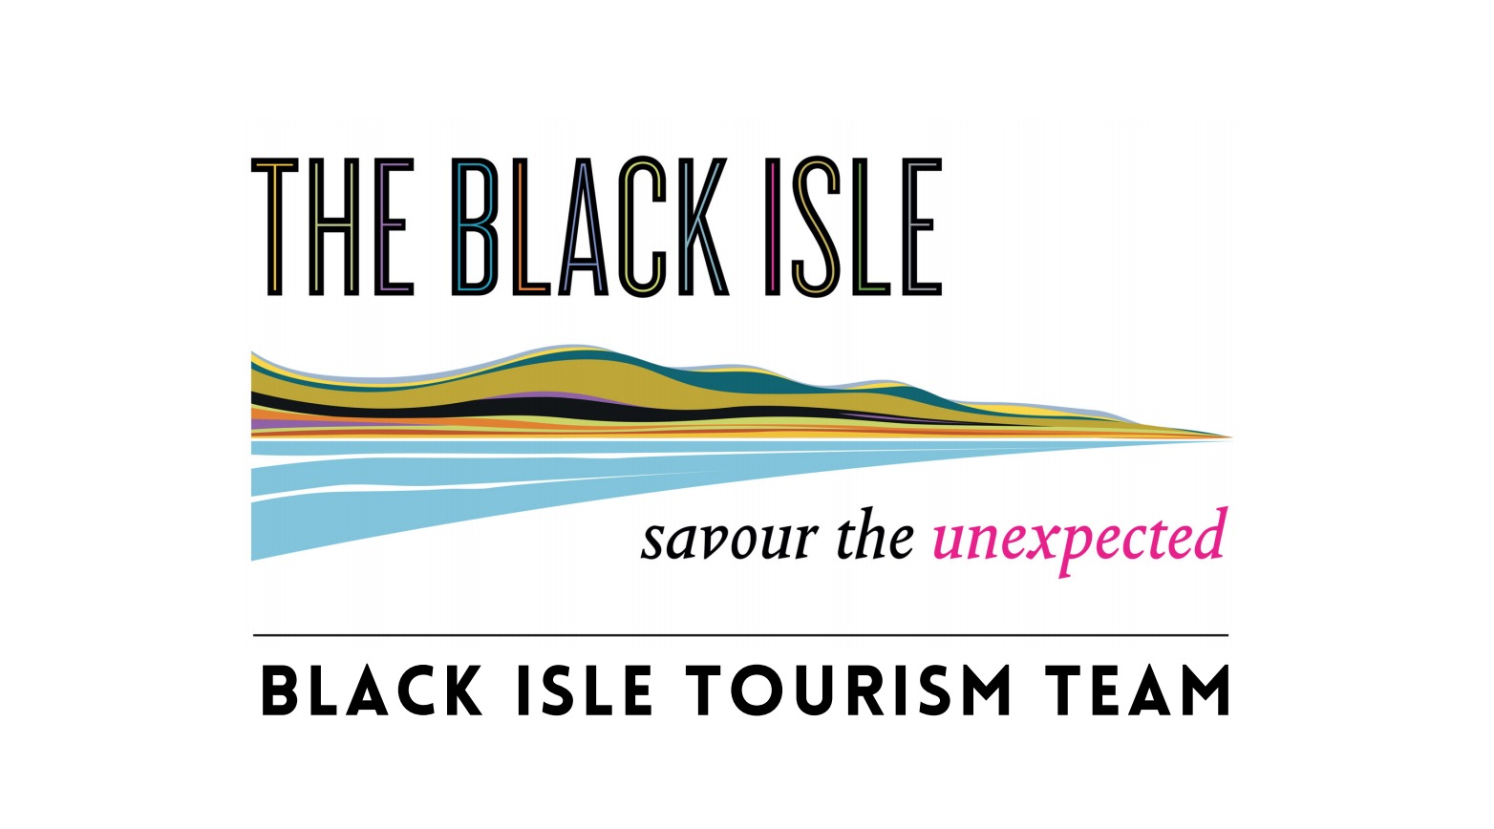

Black Isle Tourism Team
Membership form / Invoice

Welcome to the Black Isle Tourism Team! By working together, we can raise the profile of the Black Isle and help visitors and locals make the most of this beautiful place. The Black Isle Tourism Team (BITT) is hosted by the Black Isle Partnership to whom BITT membership fees are paid.

I wish to join/renew my membership of the Black Isle Tourism Team of the Black Isle Partnership for one year from today’s date

Name:

Business / Organisation:

Address:

Postcode:

Landline: Email:

Mobile:

I undertake to transfer the £40 Black Isle Tourism Team annual membership fee to the Black Isle Partnership at sort code 80 06 83 a/c 00962502, giving the following reference. (Up to 10 characters, e.g. your business name. PLEASE make this clear and unambiguous to save confusion.)

Your chosen transfer reference:

Date transfer made:

Signed: ........................................................... .. Date: ........................................................... ..

Please e-mail the form to Julian Paren at julian.paren@gmail.com, heading your e-mail BITT Membership Form.

The information given above will be held under the Data Protection Act 1998. All the information provided on this form will be held securely and only used to communicate with you about the activities of the Black Isle Tourism Team hosted by the Black Isle Partnership. The Black Isle Partnership is a Company Limited by Guarantee, Company Number $C223861.

Correspondence address: c/o Julian Paren, Company Treasurer of Black Isle Partnership, Marowan, Munlochy, Ross-shire IV8 8PF

